POPL ASSIGNMENT

2048 Game Design

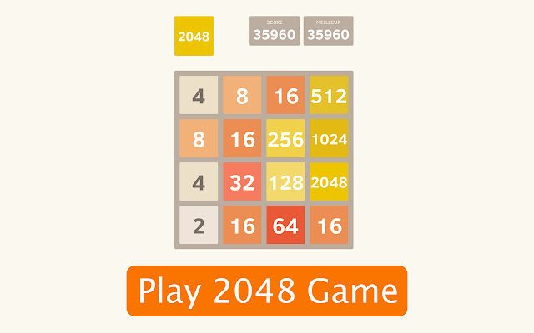

Group Members:

1. AETURI NAGA PAVAN KALYAN REDDY ID: 2018A7PS0212G
2. M V SHASHANK ID: 2018A7PS0734G
3. VOOKA RAM KISHAN ID: 2018A7PS0201

Contents

1. matrix.py
   1. Class matrix.
2. moves.py

matrix.py

Class Matrix

Functions

1. __init__ -This function is a reserved method. It is a constructor.

Arguments: self which is used to access all instances of the class and dimx, dimy tell the dimension of the matrix of the game and has a default value of 4 for both.

Attributes of the function are length, height which are the dimensions of the game board. maxTileValue which stores the maximum of the game at a particular point. Score which stores the score of the user. mtx is a 2 dimensional array which stores the integer value of the game after every move. tiles which is a 2 dimensional matrix which stores the tiile object which has the value, color and dimension of the tile.

1. buildTiles- This function instantiates the the tile class objects and store in tiles 2 dimensional array.
2. changeTileNum- This function is used to change the tile value which is reflected in gui of the game.
3. addNewTile- This function helps in adding new tile which is reflected in the gui.
4. updateGui- It updates the gui of the game when auser makes a particular move.
5. maxTileNum- This function helps in getting the maximum tile value when called and it stores the maximum value in maxTileValue attribute.
6. emptyAvailable- This function returns true if an empty place is found in the grid of the game else false.
7. checkEqualConsecutiveTiles- checks whether two tiles in adjacent are equal. It helps in merging the adjacent tiles if they are equal after a move. Returns true or false.
8. checkAddandUpdate- It stores the current move made and updates the max tile value. If max value of 2048 is not reached it adds a random tile and updates the gui else if no empty spaces left then gameover attribute is made true and winner attribute as false and if 2048 is reached then winner attribute is made true and the game stops.

10. storeMoves- stores the current values of grid in an array.

The array has size 5 which stores the previous states of the grid.

11. restore- It is called when user presses space to go back to previous state and this function updates the gui and the mtx attriubute which stores the integer values of the current state.

12. leftMove, rightMove, upMove, downMove- This function updates the mtx attribute and updates the gui based on the move made.

moves.py

Functions

1. stackLeft- This function shifts the value to the left in the grid and it stops when it sees another tile or extreme end of the matrix.
2. combineLeft- This function combines the adjacent tiles in the row of the matrix if there values are equal and also calculates the score and returns this matrix and the calculated score.
3. Transpose- This function performs similar operation to transpose of a matrix where the rows and columns are interchanged. This function helps in right, up, down movement as the matrix at current state can be transposed and stackLeft function can be used for all these three opeartions along with an additional function.
4. rotateHorizontal- This function rotates the rows of the matrix horizontally and this function is used in the performing one of the 4 operations on the matrix .
5. getLeft- It uses stackLeft to push the matrix elements of the argument given to it to left and combineLeft to add adjacent values and again stackLeft to get the final state of the matrix after performing left operation and returns this matrix and the score which is returned by the combineLeft function.
6. getRight- This function uses stackLeft, rotateHorizontal and combineLeft to get the final state of matrix given in argument after right operation and returns this matrix and the score calculated by the combineLeft function.
7. getUp- getUp uses the same above mentioned functions to change the state of the matrix in argument after up operation and returns this matrix and the score calculated by the combineLeft function.
8. getDown- getDown same as getUp, updates the argumnt matrix in down operation and returns matrix and score.